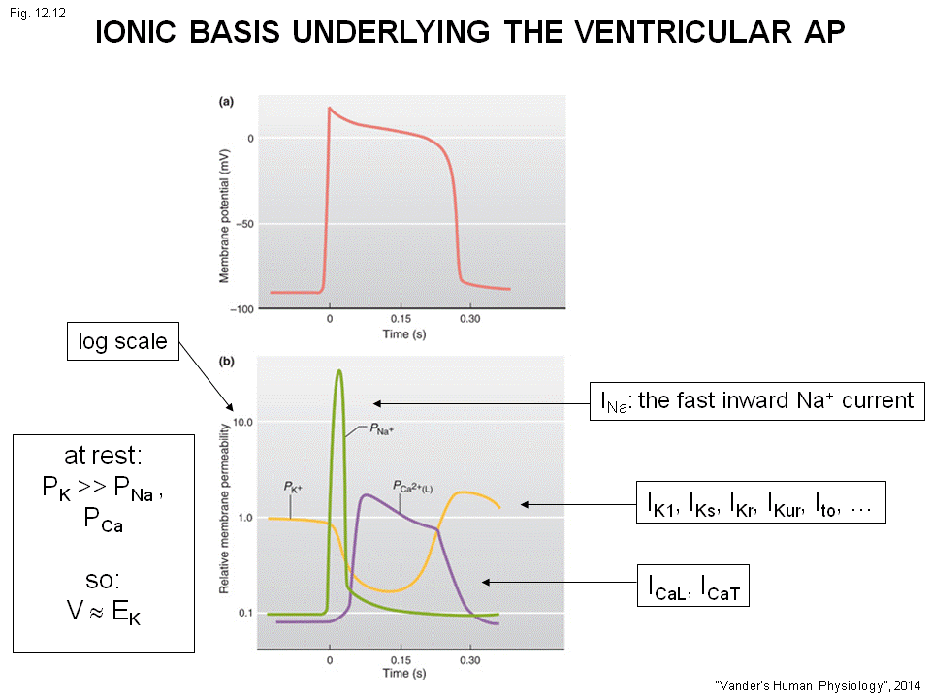
- Ventricular at resting potential is close to K+ equilibrium.
- Activated ---local circle current, voltage depolarize a bit reach the specific point , Na+ channel activated and open
- Huge flux of Na+ comes into the cell (Na+ high outside , and cell is negative charge inside at this point)
- Inactivation of Na+ channel, the Voltage is up
- K+ channels, close when the voltage goes up. Permeability of K+ will fall
- The Ca+ channel activated latter and eventually inactivate
- Later the K+ sense the voltage goes up and open, permeability K+ will go up, k+ leaves . the membrane will repolarize.
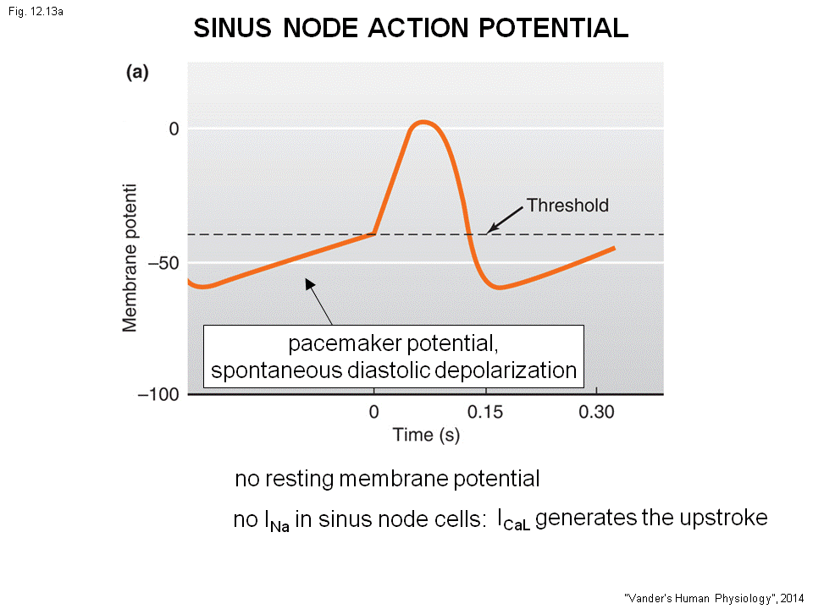
- Ica+ (L) Ica+(T), you can forget Ica+(T). The important is Ica+L . The L stands for long lasting. The open the long time.

The sinus node at heart = pace marker
The sinus node is never at rest , The V is always changing and there is no resting potential.
- Ventricle will goes from resting to action potential back to resting and stay, but not same to sinus node
- Sinuous node : pacemaker ---upstroke ---repolarization
Sinus nodes come down and slowly depolarize (goes up) , this part is called the pacemaker potential, spontanious diastoluc depolarizarion. This is the diastoluc period of heaart , during this period there is no contraction. (There is no action potential)
- During this period, there is a spontaneous depolarization of the voltage. (This happen in all the pacemaker cell)
- The upstroke is slower than the ventricular muscle. This is because the upstroke of ventricular is generated by Na+ ion in to the cell
- In sinus node, there is no Na+ current Ica++(L) is what generate the upstroke of action potential of sinus node
- 2key :1) no resting potential but a spontaneous diastolic depolarization,
2) upstroke is by ca++ influx
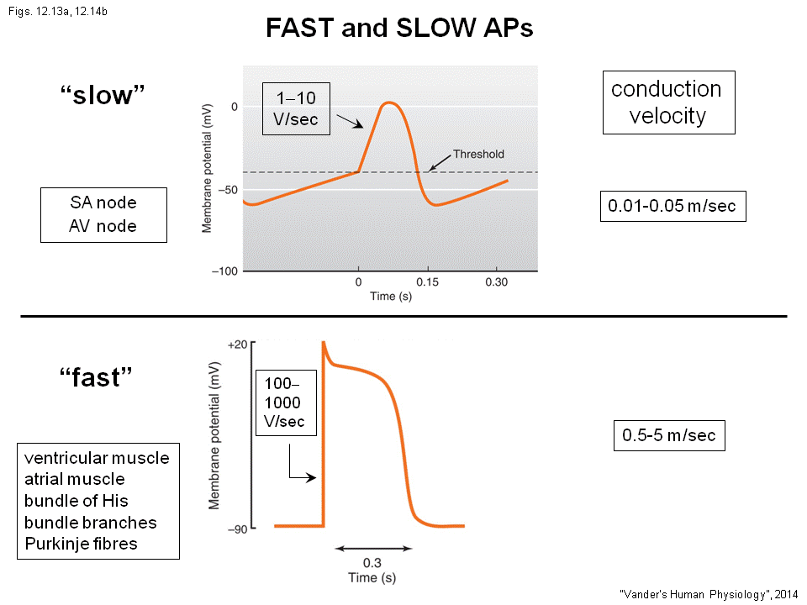

SA node is call the slow action potential , ventricular muscle is called the fast action potential.
- Slow action potential :SA, AV node
- Fast action: atrial muscle, ventricle muscle , bundle of his, bondle branches , perkinji fibers are all fast . (All except SA, AV)
Called slow and fast for 2 reasons :
In the slow (slow upstroke,slow speed)
- The upstroke take a longer time to happen
- The change magnitude : 1V/sec
- Travel slowly, Speed( condunction velocity) : 0.01 ~0.05 m/sec
In the fast (fast upstroke, fast speed)
- Upstroke fast
- 100 – 100V/sec (100 times faster than slow) (the rate of rise control the speed of travel)
- Travel quickly, Speed( condunction velocity) : 0.5 ~5 m/sec

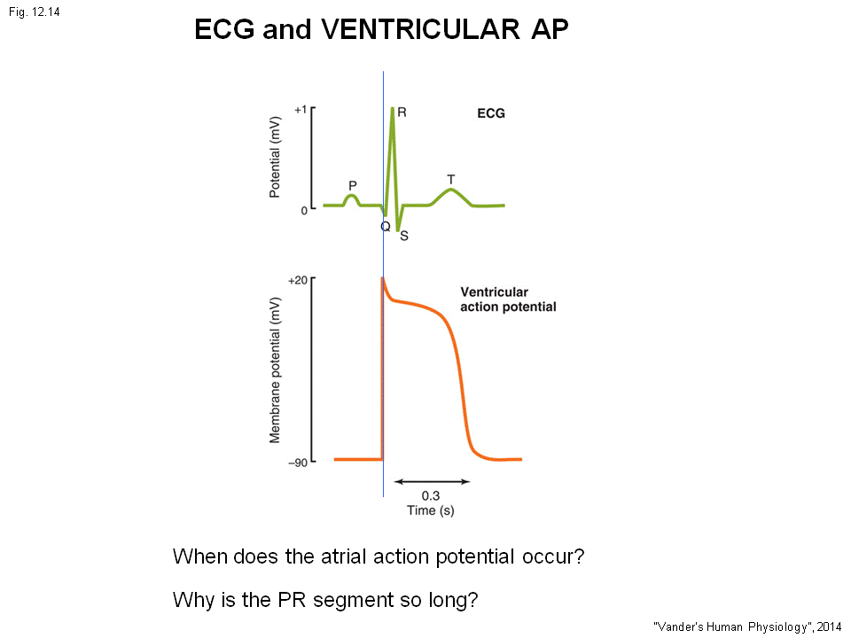
ECG at the body, stick one microelectrode on the surface of body measure the action potential.
Top--- ECG
Bottom –action potential of the ventricle cell
- P wave is the atriale depolarizaiton
- QRS ventricular depolarization
- upstorke of ventriclular cell is during QRS cell ( this cell is activated early in ventricle so around Q, is the cell is activated late it will activated around S.)
- T wave is generated by repolarization wave in ventricular muscle (So any cell will have repolarization during T wave)
When does the atrial action potential ? depolarize – p wave, but why no repolarization, atrial action potential is shorter so they repolarize during QrS complex or just before the complex. (you can see a small deep beforre QRS)
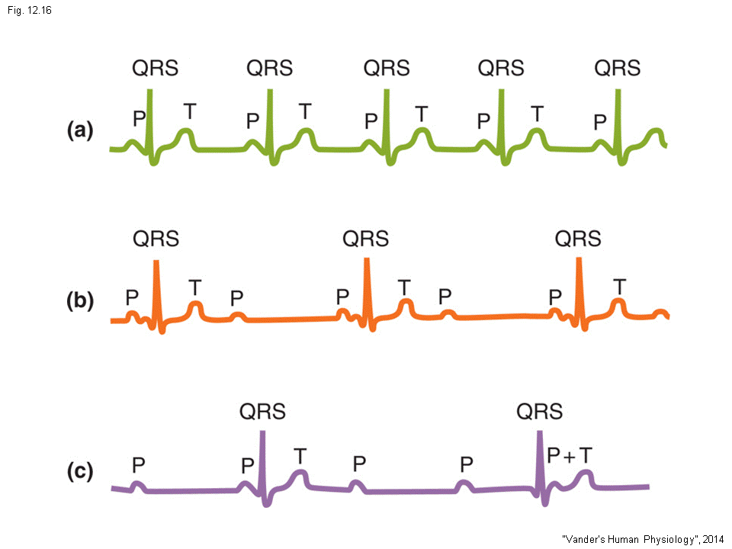
The Pr segment is the end of P to beginning of QRS (no need to memorize ), this is long , nothing happen during the heart . In P segment, the action potential enter AV node (slowly travel, half through P wave) , bundle of his, branching and perkinje (travel quick) lastly to the muscle.
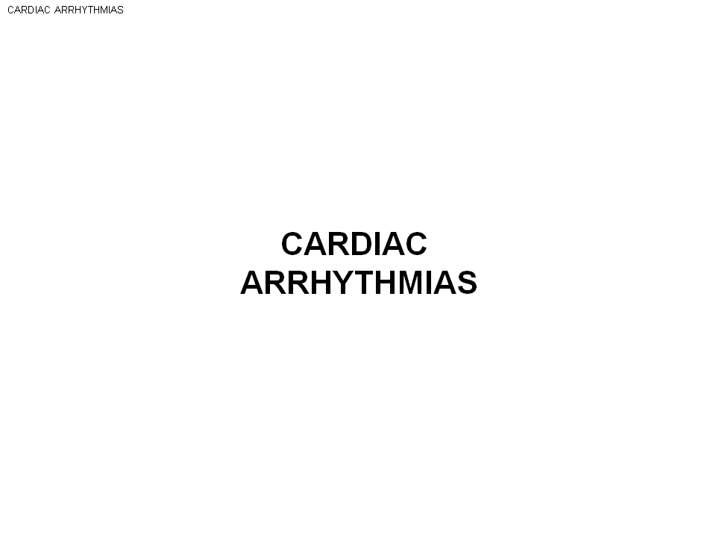

This is the hand drawing
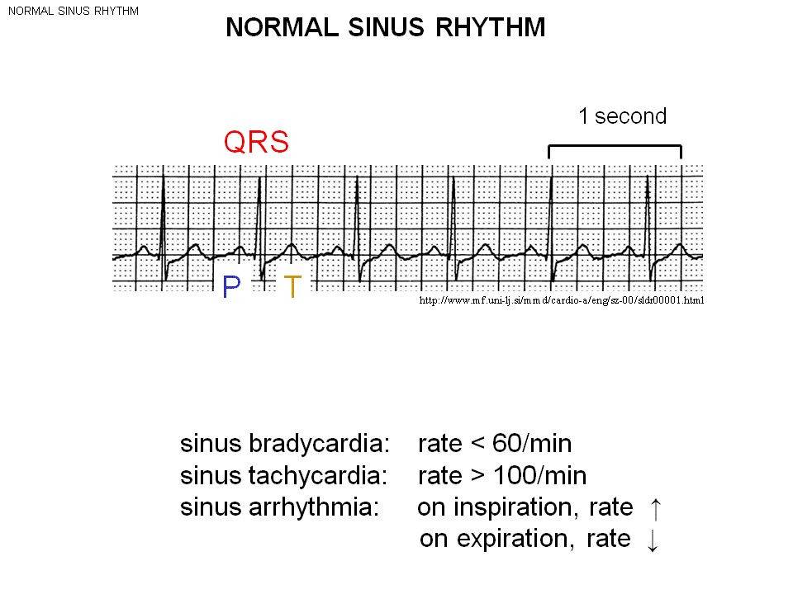
This is the ECG, sinus rhythm ( = bracuse the pacemaker is from here. )
Heart rate = 60/min
Falls <60 /min ---- sinus brady (slow ) cardia.
Normal person : When sleep <60/min, sinus brady (slow ) cardia is not pathological
>100/min ----- sinus tachy (fast) cardia. Exercising.
Id at rest >100, is a inappropriate sinus tachycardia
Sinus arrhythmia : take breath in (heart rate increase) take breath out( heart rate decrease )
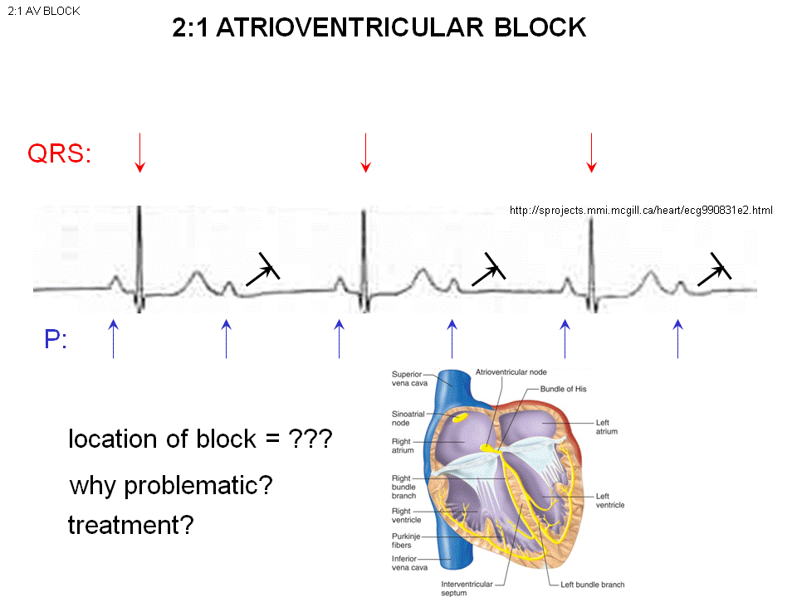
- As you get older and unhealthy , this will gone.
The second P wave is not followd by a QRScomplex. The QRS is generated by activation ventricle, (here disappear means the action potential did not get down to the ventricle )
- The action potential is blocked
3rd wave normal ---blocked -----normal ---Blocked
We call this atrioventricular block. There is (2:1) –for 2 atrial activation, there is only one ventricle activation.
The block can happen inside the AV node or bundle of his or both bundle of branches.
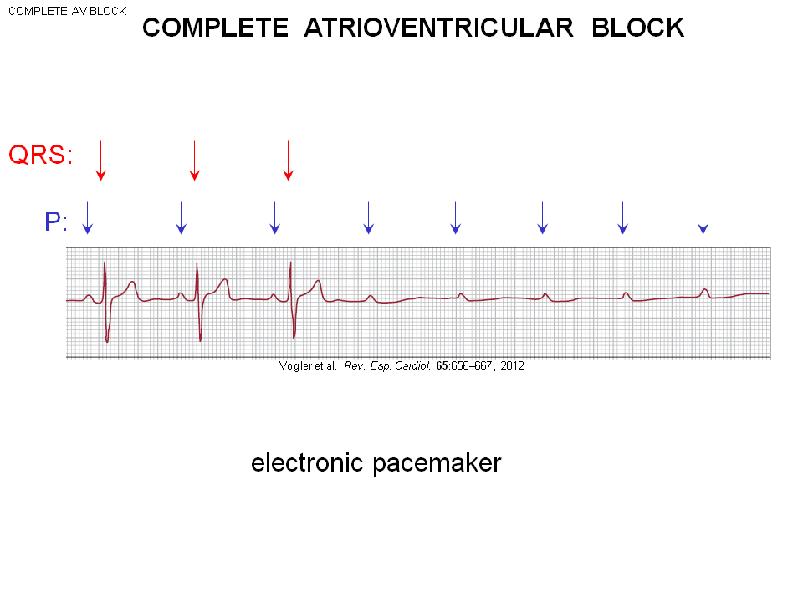

The lost of sinus rhythm in the following. ---no more QRS complex in ventricle
Complete atrioventricular block
--this person will die
--is QRS come back than call “transient atrioventricular block” if don’t “permiment atrioventricular block”, have to put in a pace maker to stimulate the ventricular muscle to fire.
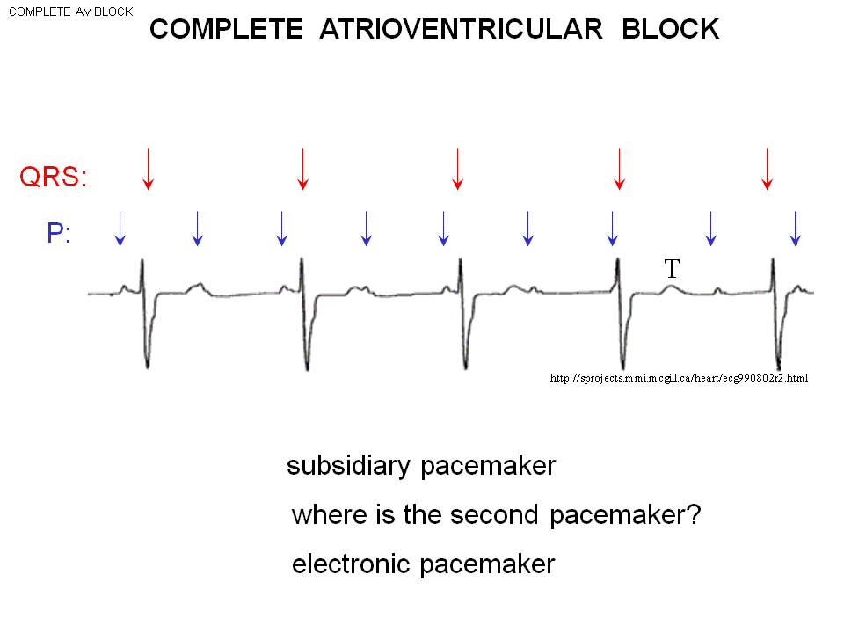
Also complete atrioventricular block, the action potential did not go to ventricle
- but the QRS complex do show up but in a much slower rate than the P wave.
- This can because of the second pacemaker cell other than SA node (somewhere in the ventricle probabiliy in the pirkinji fibers)
- Problem: The rate of ventricluar pacemaker is too slow
- Called subsidiary pacemaker (primary pace maker is SA node)
- This can be slow as 20/min and the pacemaker can suddenly stop.
- 2 pacemaker in heart , they do there own thing don’t communicate.
- Electronic pacemaker to help

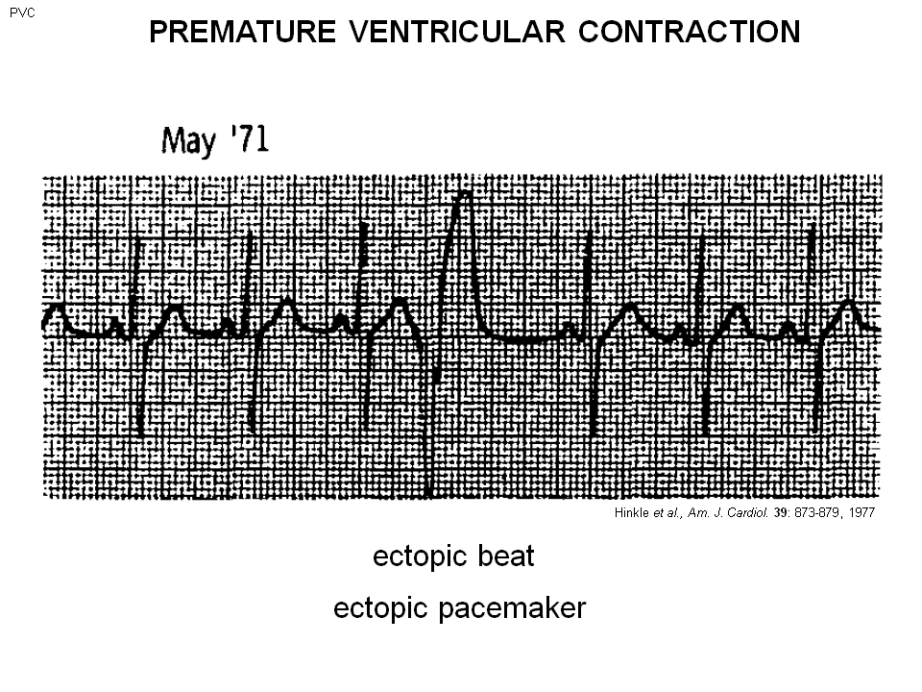

Normal sinus rhythm –PQRS all show up, but than meet a huge QRS complex than a huge T wave.
- Ventricle is activated permaturely (earlier than it should be)
- Ectopic pacemaker = pacemaker in a wrong place , shouldn’t be here.
- This guy have a heart attack .
- Permiture can also happen in AVnode, atrium…..but this is from ventricle
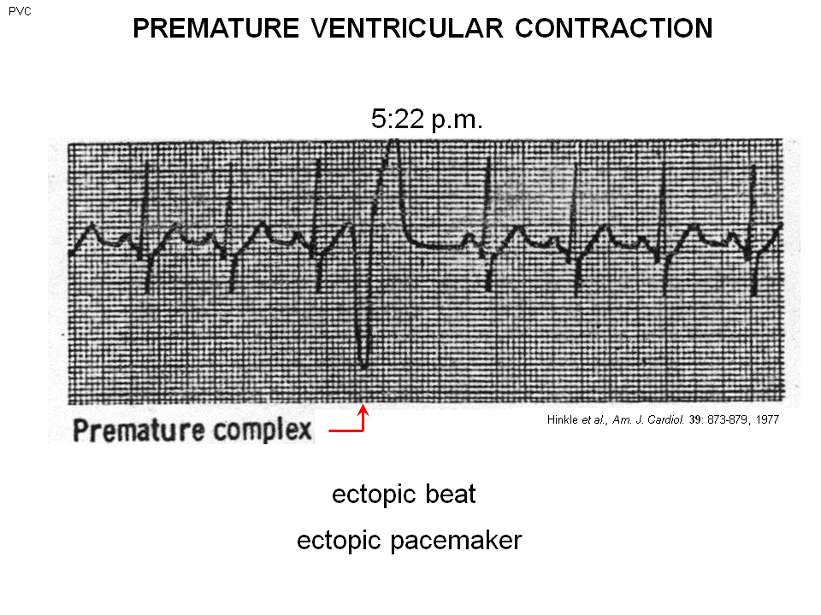
- A few minutes later you see the next picture

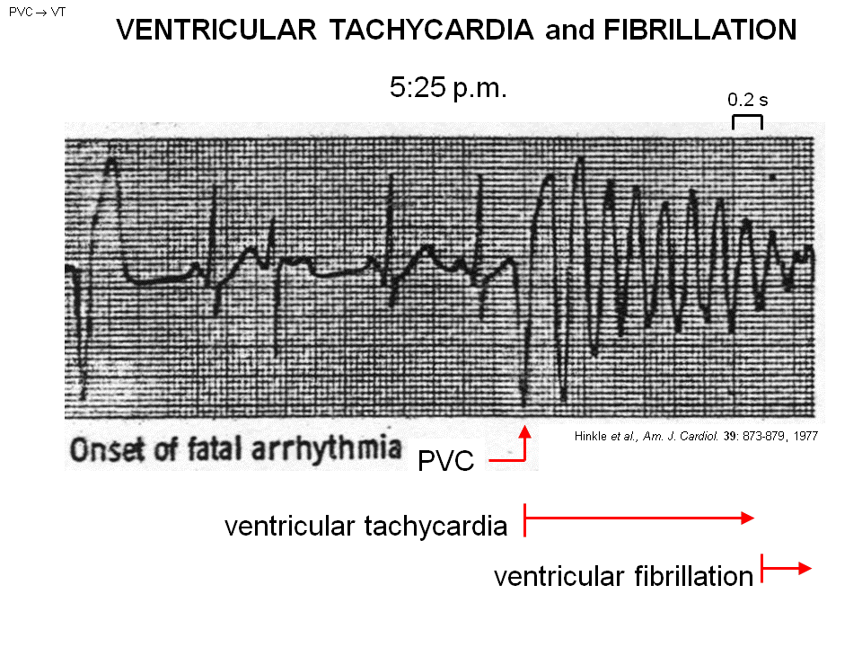
After PVC(Premature ventricular contractions), he didn’t come back to normal sinus rhythm like previous.
- This different rhythm is called : ventricular tachycardia, a very rapid rhythm
- QRS and T wave superimpose
- QRS – QRS --- QRS ---- QRS
- The time between QRS is 0.2 sec, the fast rate = ventricle pumping fast
- ventricle pumping fast = the blood pump out = 0. The ventricle need to take time to fill, if 5 times per sec (0.2 sec) there is activaion from atrium, the centricle can’t have time to fill. No cardiac output!
- Then go to ventricular fibrillation

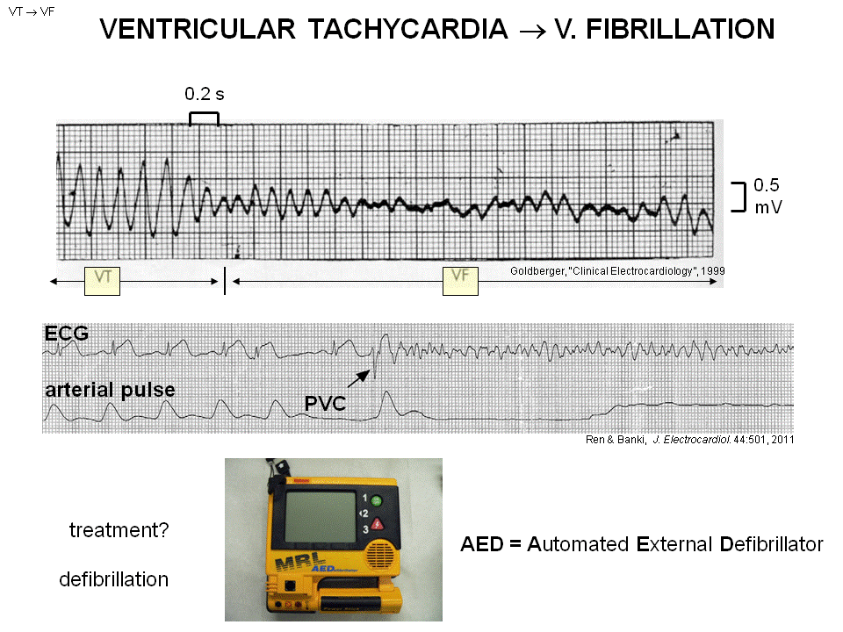

- You see the low amplitude and disorganize, irregular
- ventricular fibrillation = there is mutiple wavelength of action potential in ventricle in different direction give a irregular activity.
- Imagine a bag of worms, they all move together –lost coordinate contraction of ventricle
- The amount of blood ejected = 0
- The cardiac output = 0
- The blood pressure = 0
- The ECG on top show a patient goes from normal rhythm to ventricular fibrillation, no more blood out put --- 3~4 die
- Treatment: defibrillation (AED) –apply a high amplitude shock to the heart depolarize all the cells sinous node take over, and restore sinus rhythm.

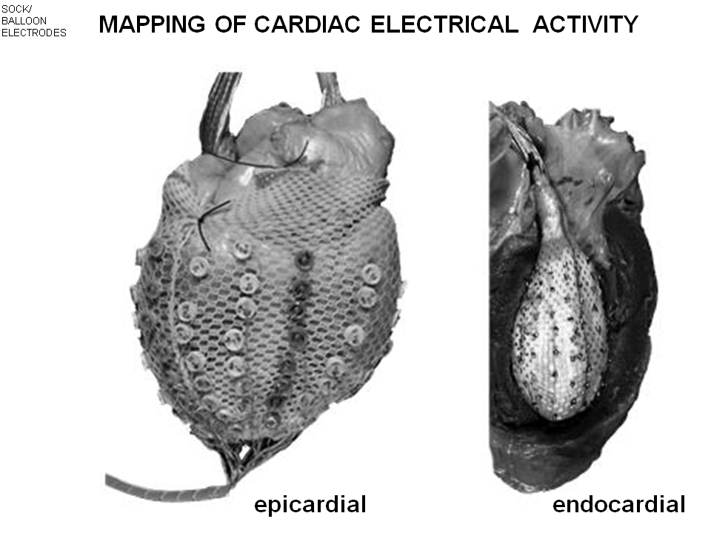

Making measurement in the heart and pick action potential
- This is a shock electrode
- 46 electrode around ventrical
- Collact the recording project 3D to 2D tell the activation map

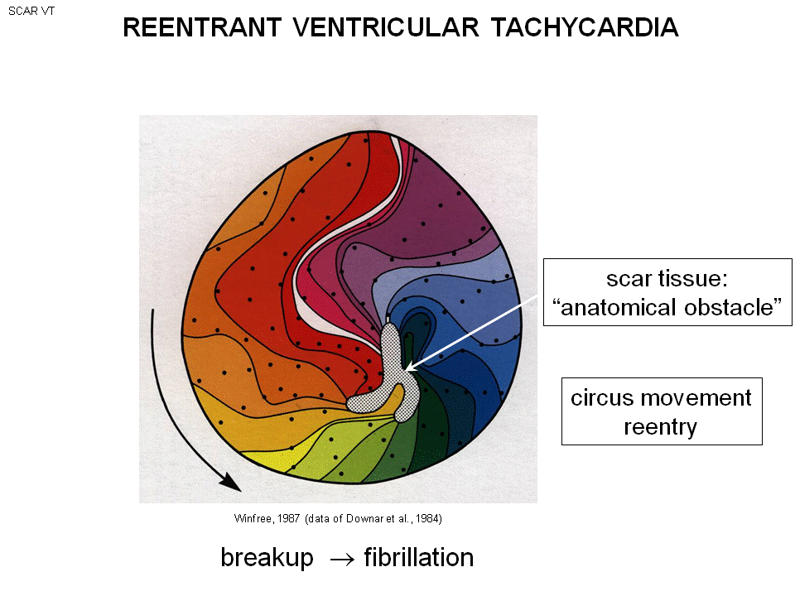
A man have heart attack before, keep going to VT. Do surgery, and measure by shock electrode. The black dot indicate the electrode. The middle is the bottom of the heart, as moving outward of heart, u move outward.
- A pieces of the muscle in ventricle has died = the middle grey area = scar tissue = in-excitable
- 200m sec the action potential have gone around the circle and back to where it started
- Re-entrant motion, once the part have done first action potential, they do the second….(note is the same action potential keep going around) so the action potential goes around second time, third time … it’s the same action potential!
- This happen when there is a obstacle (here the central scar)
- Called circus movement re-entry (Imagine the tent with a ring on the top, the animal move around in the circus)
- The ECG diagram show above : ppl go from normal sinus rhythm to PVC to ventricular tachycardia to ventricular fibrillation ----these are the people have heart attack
- There is a clot forming in one of the coronary artery or in the main branches that comes off, if the clot form it blot the artery. The heart no longer get Oxygen, glocus and so on..The waste product( CO2) is accumulating PH fall , affect the heart physiology and change the action potential. Area that has fast action potential become slow, cause cardiac arrthymia. The PVC comes and make the reentrant motion (not necessary circus but reentrant motion) and this cause the to ventricular tachycardia as this spin around ( 5 times per sec ----compare to 3 times per sec normal heart rate ) the muscle fatigue. The muslce cell have diffenet electron properties, at the 6 times of wave. Part of the muslce refuse to excited (refractery to excitation stimulation.) , this area refuse to produce action potential , but the area beside is happy to conduct. The single activation wavefront will breack in to two. The two wavefront go into different direction. Freagmentation of single wavefront to mutiple wavefront If two of them heat, make transition from ventricular tachycardia (single circuit) to ventricular fibrillation (mutiple circuit, the break up of the single circuit)

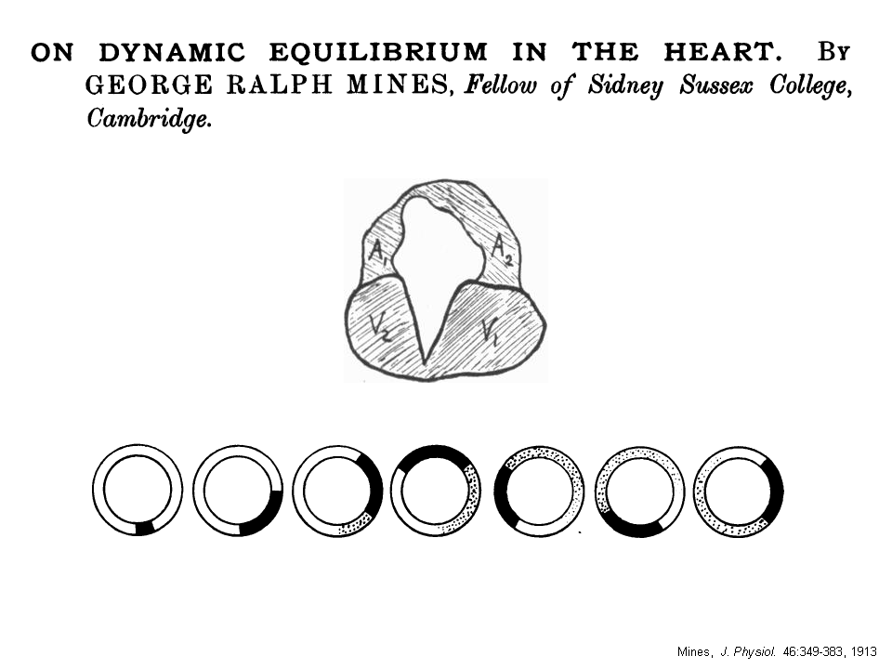

He took at heart and cut out the chunk of muscle in it and make a ring like
- If he stimulate the point, the action potential can move around the ring and keep going around the ring.
- Re-entrant motion

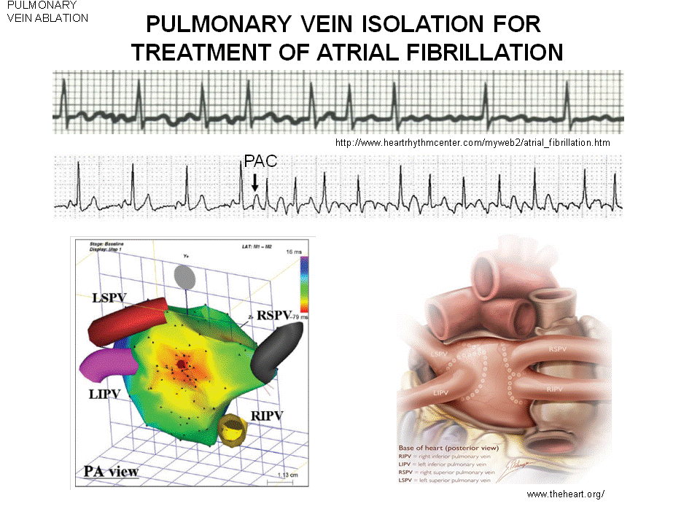
Atrial Fibrillation is the most common arrthymia.
- Same as V. Fibrillation, the multiple action potential circulation around in the atrium in a specific time.
- Atrium no longer pumping, but this is not the problem.
- ECG: continuous activity, the small amplitude wave is from the atrium and irregular. You have the irregular input to hit the AV node, AV node response in an irregular way. The QRS (ventricular) is irregular. Net result is less efficient pumping by the ventricles because the signals they receive are disorganized and "random.”
- How the Atrial Fibrillation start ?
- The premature of atrium contraction (PAC) . (similar to before, a premature ventricular contraction)
- PAC initiate the re-entrant motion
- This is the map that shows the sends out a premature beat, generate the action potential spread through the atrium and produce the PAC.
- The picture show a 4 veins, its pulmonary vein left atrium . There is cells in pulmonary vein that occasionally send out action potential and that will travel in the veins into the atrium and start up the atrial Fibrillation.
- Treatment is surgical in nature: action potential blocking scar tissues are purposefully created by killing the cells around the pulmonary vein action pace makers by "burning" or "freezing" them with probes. (stop the action potential traveling, no PAC)

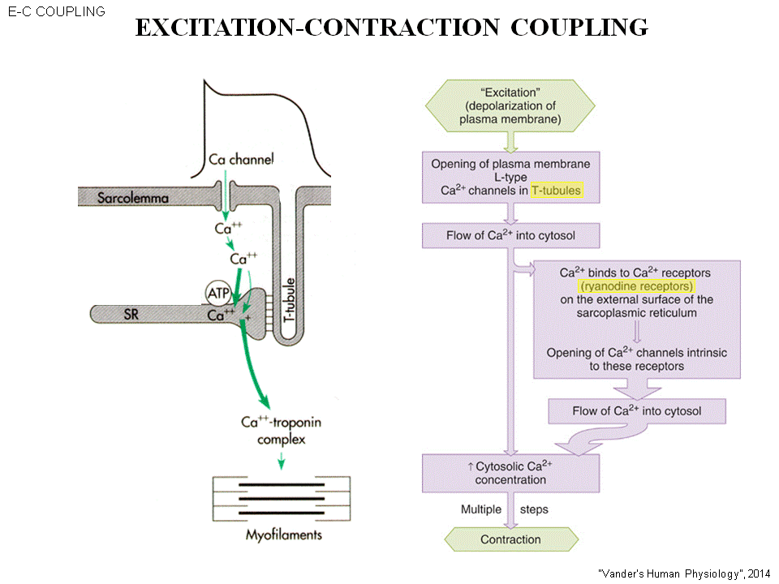

Excitation- contraction coupling. The trigger of contraction is the same as muscle. The cell have undergo action potential.
- The cell with sarcolemma, there is a lot of sarcoplasmic reticulum in the cardiac cell. This organelle is filled with Ca++ .
- Recall when the Ca++ channel open and close during action potential. (the red circle ) During this period of time , the Ca++ is influx into the cytoplasm. (Through the I Ca++(L))
- this Ca++ will bind in to the receptor on a membrane of a sarcoplasmic reticulum, the receptor is called ryanodine receptor. This receptor is also a coupled Ca++ channel. this Ca++ bind to the ryanodine receptor and the channel will open. The ca++ which is high concentration in SR will leave, and go to the cytoplasm attach to the troponin and activation of myosin( the cross bridges) action
- This process is called Excitation- contraction coupling. This means excitation and the process involve in all of these steps have to go on before the contraction

